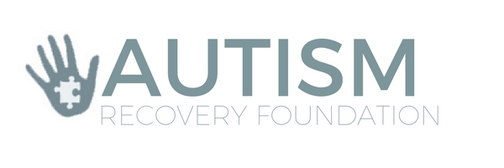

Board of Directors Meeting Minutes
March 8th 2017 - 6:30 p.m.
Lovaas Institute Conference Room
3rd Floor, Calhoun Beach Club, Minneapolis
Board Members:
Present: Randall Bachman, Anna Theisen-Olson, Kim Schulze, Eric Larsson, Lisa Barsness,
Excused: Kathryn Nordberg, John Mulligan, Tammy Meyer, Asneth Omare, Peggy Howell, Jennifer Larson
Others Present: Amy Sippl

Proceedings:

Review of Minutes from January Meeting
- Attendees were provided with meeting notes from the January board meeting. Minutes were reviewed by the board and approved to be submitted without changes.

Welcome to Anna Theisen-Olson
- Chairperson Randall Bachman welcomed and introduced Anna Theisen-Olson to the Autism Recovery Foundation board. Anna is a parent, advocate and experienced non-profit volunteer. Welcome Anna!

ARF Financials
- Bachman reviewed the current financials (see attached documents). The current account balance is $24,977.67. There were $2617.93 of additional deposits from sponsorships and Inside Edge since the last meeting. There were $4068 in expenses including 4 scholarships.
- Bachman has completed and filed the IRS 990 document for 2016.

Fall Fundraising Event
- Board members reviewed proceeding with the 2017 fall fundraising event:
  - Board Member Tammy Meyer has agreed to continue planning for a 2017 fundraising event. The date has been set for October 28, 2017 at the Humphrey Center in Minneapolis.
    - Other recommendations included having the involvement of adults with ASD and involvement from Minnesota Life College and Erik’s Ranch.
    - Ideas to secure a “major” event sponsor of $10,000 or more were also discussed. Attached is a summary list of all of the donors from previous years.

MNABA Conference Sponsorship
- Bachman was approached by Michelle Traub the MNABA Conference Chair about sponsorship of the September 2017 conference. Board Member Eric Larsson motioned for ARF to supply a $300 sponsorship for the event. Motion carried.

MN-CCD Conference Sponsorship
- Bachman reviewed sponsorship of the October 4, 2017 MN-CCD Conference focusing on “Wellness” of individuals with disabilities. The table would be right before our fall event and may be a good time to sell additional tickets.

Long-Term Fundraising and Grants
- Bachman reviewed coordination with Kathy Kulkielka at The Guthrie Theater to engage in consulting to attract major gifts and bequests. Board Members Tammy Meyer, John Mulligan, and Jennifer Larson have agreed to participate in planning for long-term fund development.

Committee Reports
- Scholarship Committee Chair Lisa Barsness reported that 4 of the 5 scholarship checks had been cashed. Amy Sippl will verify that the checks have been cashed.
- Canteen Grant Committee Chair Asneth Omare was not present at the meeting, however we have 4 current canteen grants under review. A recommendation to increase awareness among the ABA providers, including Fraser was also made.

Legislation
- Bachman and Board Member Eric Larsson reported on the 2017 Legislative session including:
  - MN-CCD Tuesdays at the Capitol on January 17, 2017
  - EIDBI Benefit
  - MA-TEFERA Parental Fee Bill
  - Revisions to the Affordable Care Act, including Medicaid block grants
  - BCBA Licensure bill
- Board members are encouraged to contact Bachman or Larsson with any questions about legislative efforts and this year’s session.

Adjournment
- Meeting adjourned at 7:45 p.m.
  - The next board meeting is set for Wednesday May 17th from 6:30-8:30 p.m. at the Calhoun Beach Club.
  - Board meetings for 2017 set at: July 12; September 13; October 11
  - Amy Sippl will set up video capabilities via Skype/WebEx if needed.

